Exercises Lecture 10 – Networking and Integrating the Web

Aim: This exercise will help you learn how to use networking classes and will take you through the process of using Qt WebKit to create an Web-enabled application.
Duration: 1h

© 2011 Nokia Corporation and its Subsidiary(-ies).

The enclosed Qt Materials are provided under the Creative Commons Attribution-Share Alike 2.5 License Agreement.



The full license text is available here: http://creativecommons.org/licenses/by-sa/2.5/legalcode.

Nokia, Qt and the Nokia and Qt logos are the registered trademarks of Nokia Corporation in Finland and other countries worldwide.

Creating a simple web browser
This exercise come with a source code package. Extract that package into a working directory. The content is a number of projects that serve as starting points for each step of this exercise.
In this first step, you will implement a basic web browser application. Start from the webbrowser project. The project contains a basic implementation that shows a window with some widgets.
First task is to add a QWebView widget to the design. There is a member variable, browser, for holding it, so instantiate a QWebView widget and hold the pointer in the designated variable. Also, add the web view to the mainLayout.
Next, you will take care of the back, forward and reload buttons. You do this by retrieving the corresponding QAction objects from the QWebView. You can retrieve the actions Back, Forward and Reload using the QWebView::pageAction() method. Assign the actions to the buttons using the setDefaultAction method. This should give the buttons an icon, some text and functionality.
Now make your browser load the URL provided in the address bar whenever the loadPage() slot is called. The method QUrl::fromUserInput() can transform the string given by the user into a proper URL. Then ask the QWebView to load the URL. To make the slot work, connect the returnPressed signal from the addressBar to the loadPage slot. You should now be able to use the browser for basic browsing.
Letting the user set the URL only solves half the problem. Web pages sometimes redirect the browser. To handle this, connect the urlChanged(QUrl) signal from the browser to the updateAddressBar(QUrl) slot.
In the updateAddressBar slot, set the text of the address bar to the given URL. You can convert a QUrl object to a QString using the toString method.

Harvesting the Web
Providing users with web browsing abilities is good, however, it is also interesting to be able to traverse the web programatically. The imagespider project is a starting point for an application that acts like a web browser, but also harvests images from the web pages visited.

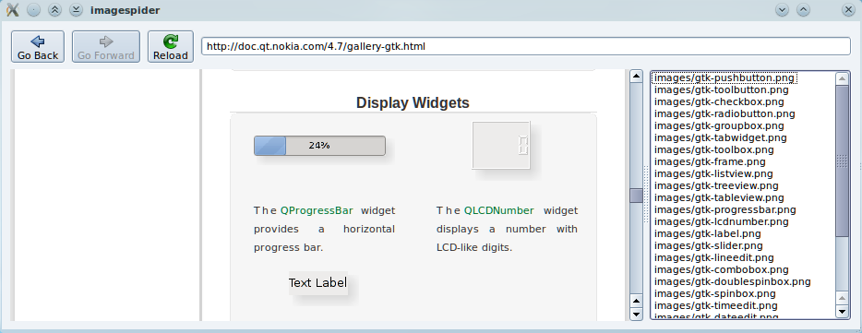
The idea is that the scanPageForImages slot is called as soon as a page has been loaded. It extracts all img tags and extracts the src attributes from them, populating the list of images to the right.
First, connect the scanPageForImages slot to the loadFinished(bool) signal of the QWebView.
In the scanPageForImages() slot, the plan is to retrieve all img tags and add their src attributes to the images string list. To be able to access the img elements, you first need access to the main frame of the web page. You get it through the web view as shown below.
QWebFrame *frame = browser->page()->mainFrame();
From the frame a QWebElementList can be retrieved using the findAllElements("img") method. You can iterate over every QWebElement using the foreach macro.
For each element, use the attribute method to retrieve the value of the src attribute. Append this value to the string list.
When visiting a web page, wait for the page to fully load. You can see that this has happened when the reload button next to the address bar is enabled. When that happens, the list to the right should fill with image paths. You have harvested the page of its images.

UDP Chat
Until now, we have relied on the HTTP protocol, which is based on TCP/IP. For this next step, you will use UPD datagrams over IP directly. Use the broadcastchat project as the starting point.
The application provides a chat program user interface and the methods needed to implement a simple network chat system. The goal for this step is to add the UDP networking functions needed to transmit and receive messages.

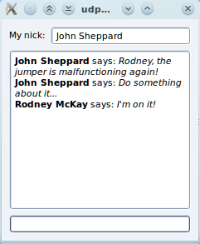
Start by implementing the startNetworking() method. In it create a UDP socket and bind it to the given port and the broadcast host address. Store the pointer to the socket in the socket member variable. Make sure to pass the QudpSocket::ShareAddress bind mode flag when binding the socket, so that you can run another copy of your program on the same machine for testing purposes.
Having created the socket, connect the readyRead signal of the socket to the processPendingDatagrams slot to receive notifications whenever a new datagram arrives.
In the processPendingDatagrams slot, use the following code to read the next datagram into a buffer.
QByteArray buffer;
buffer.resize(socket->pendingDatagramSize());
socket->readDatagram(buffer.data(), buffer.size());
Now use decodeMessage to convert the buffer contents into a pair of strings that carry the nickname of the sender and the message body. Pass these onto the showMessage with appropriate parameters as shown below to have the message displayed in the window.
showMessage(pair.first, pair.second);
Finally implement the sendMessage() slot. Use the encodeMessage method to convert the (nick, message) pair into an opaque byte array and broadcast the message through the socket using the writeDatagram method. Broadcast to all on the network by providing the host address QHostAddress::Broadcast. Also, use the socket->localPort() method to retrieve the port to use.

Solution Tips

Step 2
To get all image tags from the page, use the QWebFrame::findAllElements() call and pass it the “img” search string.
QWebElementCollection imageTags = frame->findAllElements("img");
Then loop over the result and use QWebElement::attribute() to ask for the “src” attribute. Finally add its value to the list.
foreach(QWebElement element, imageTags) {
QString src = element.attribute("src");
if(!src.isEmpty())
images.append(src);
}

Step 3
To bind the UDP socket, use the following call:
socket->bind(QHostAddress::Broadcast,
port, QUdpSocket::ShareAddress);
To broadcast to all stations in the local network, use QHostAddress::Broadcast as the destination address for QUdpSocket::writeDatagram(). Be sure to use the same port as for receiving messages.

